**Algerian Forest Fires: Forecasting Fire Risk Using FWI and Regression Models**

**Objective**

The goal of this project was to analyze the Algerian Forest Fires dataset and develop regression models to predict the Fire Weather Index (FWI), a numerical indicator of fire danger, based on various weather and fire-related features.

**Why This Project?**

Forest fires are a growing concern worldwide, and being able to predict fire risk can aid in timely preventive measures. This dataset covers two regions in Algeria: **Bejaia** and **Sidi-Bel Abbes**, providing environmental measurements from June to September. This made it a great candidate for regression-based prediction.

**Dataset Summary**

**Source**: Algerian Forest Fires Dataset (June–September 2012)  
**Regions**: Bejaia (Northeast Algeria) and Sidi Bel-Abbes (Northwest Algeria)  
**Instances**: 244 (122 per region)  
**Classes**: 138 'fire', 106 'not fire'  
**Features**: 11 input features + 1 output class

**Feature Dictionary & Business Relevance**

|  |  |  |
| --- | --- | --- |
| **Feature** | **Description** | **Why It Matters** |
| **day/month/year** | Date of observation | Temporal features (removed before modeling) |
| **Temperature (Temp)** | Maximum daily temperature in Celsius (22 to 42) | Higher temps dry vegetation → higher fire risk |
| **Relative Humidity (RH)** | Humidity % (21 to 90) | Lower RH → more dryness → higher fire probability |
| **Wind Speed (Ws)** | Wind in km/h (6 to 29) | Wind spreads fires more rapidly |
| **Rain** | Precipitation in mm (0 to 16.8) | Rain reduces ignition probability |
| **FFMC** | Fine Fuel Moisture Code (28.6 to 92.5) | Dry surface fuel ignition potential |
| **DMC** | Duff Moisture Code (1.1 to 65.9) | Moisture in shallow organic layers |
| **DC** | Drought Code (7 to 220.4) | Deep fuel layer dryness — long-term fire potential |
| **ISI** | Initial Spread Index (0 to 18.5) | Combines wind & FFMC to estimate spread rate |
| **BUI** | Build-Up Index (1.1 to 68) | Fuel availability from DMC & DC |
| **FWI** | Fire Weather Index (0 to 31.1) | Final calculated index for fire danger — our target variable |
| **Classes** | 'fire' or 'not fire' | Used for class distribution and correlation reference |

**Data Understanding and Cleaning**

* **Identified structural issues**: One row (index 122) was a textual header separating the regions. It was removed for clean processing.
* **Added a 'Region' column**: Rows 0–121 were labeled Region 0 (Bejaia), and rows 123–end as Region 1 (Sidi-Bel).
* **Converted all numeric-looking object columns** (e.g., Temperature, RH, Wind Speed) to proper numeric data types.
* **Dropped irrelevant features**: Columns like day, month, and year were removed since they added little predictive value.
* **Mapped class labels**: Converted Classes into binary values — fire = 1, not fire = 0.

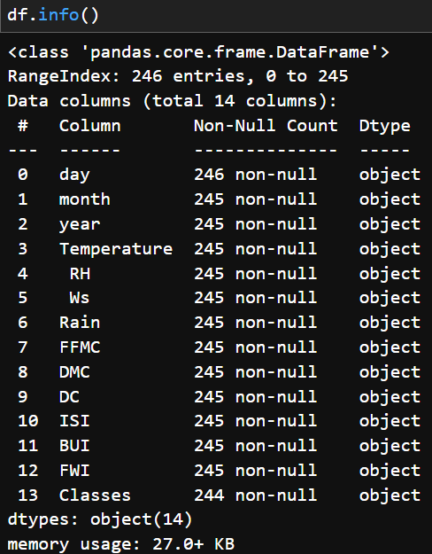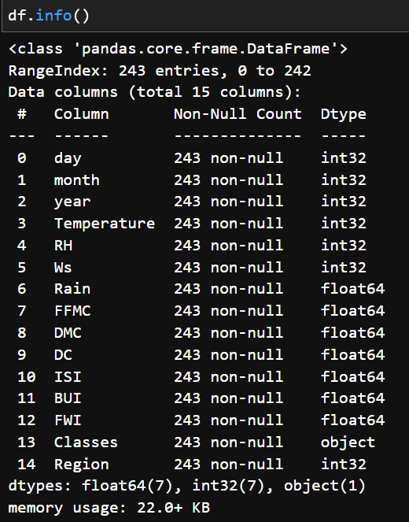

***Before*** ***After***

**Preprocessing Steps**

* **Handled missing values** by removing affected rows entirely.
* **Converted all columns** to appropriate numeric types.
* **Created df2**: a numeric dataset for modeling.
* A colorful squares with numbers

  AI-generated content may be incorrect.**Dropped highly correlated feature BUI** to reduce multicollinearity. This was identified via a correlation heatmap.

**Data Scaling**

Applied **StandardScaler** to normalize features.

**Why -** To ensure features are on the same scale so models like Ridge and Lasso can apply regularization correctly.

**Impact** - Boxplots showed all features centered similarly which improves training stability.

*Impact of Scaling on Different Features*

**Exploratory Data Analysis**

**Class Distribution**:

**Pie chart** revealed class imbalance: ~56% fire, ~44% not fire.

**Histograms**: Showed feature distributions and skewness.

**Heatmap**: Helped visualize correlations, guiding feature selection and model design.

**Monthly Trends**:

Bar chart for Region 1 showed peak fire months (e.g., June–September).

**Why** : Helps validate seasonal fire patterns.

**Modeling Approach**

* **Target variable**: FWI (Fire Weather Index)
* **Features**: Included Temperature, RH, Wind Speed, Rain, FFMC, DMC, DC, ISI, Class, and Region
* **Train/Test Split**: 75% training, 25% testing

**The models used in this project -**

1. **Linear Regression**

Linear regression was used as a baseline model. It attempts to model the relationship between the input features and the FWI value by fitting a straight line. Since the dataset was clean and mostly linearly related, this model performed exceptionally well.

* **Output:** Continuous predicted FWI values (e.g., 3.24, 15.9, 29.2)
* **Interpretation:** These values represent the estimated severity of fire risk given the environmental conditions.
* **Performance:** R² = 0.989, MAE = 0.465
* **Why**: Baseline model to measure how well basic assumptions fit.
* **Impact**: Delivered an excellent R² of **0.989**, indicating strong predictive power.

1. **Lasso Regression**

Lasso Regression uses **L1 regularization**, which not only reduces the magnitude of coefficients but can also shrink some of them to **exactly zero** effectively performing **feature selection**.

* **Output**: Similar continuous FWI predictions.
* **Interpretation**: Useful if we want a simpler model that uses fewer features.
* **Performance**: R² = 0.954, MAE = 1.08
* **Trade-off**: Slightly worse performance due to possible elimination of relevant variables.
* **Why?**: To perform feature selection and reduce overfitting.
* A graph with blue dots

  AI-generated content may be incorrect.**Impact**: R² dropped to **0.954**, and MAE increased, indicating it may have dropped useful features.

1. **Ridge Regression**

Ridge Regression applies L2 regularization, which penalizes large coefficients but does not force any coefficient to zero. It is useful when multicollinearity exists or we want a more stable model.

* **Output:** Predicted FWI values across the same continuous range.
* **Performance:** R² = 0.987, MAE = 0.503
* **Benefit:** Prevents overfitting while still using all available features.
* **Why:** Adds penalty to coefficients without removing features.
* A graph with blue dots

  AI-generated content may be incorrect.**Impact:** Balanced performance with R² of 0.987 which is a good trade-off between bias and variance.

**Sample Prediction**

***Prediction of FWI based on sample values***

**Model Export for Reusability**

Exported the scaler and final Ridge model using pickle for later deployment:

**Import pickle**

**pickle.dump(scaler, open('scaler.pickle', 'wb'))**

**pickle.dump(ridge_model, open('ridge.pickle', 'wb'))**

**Key Learnings and Reflections**

* **Cleaning matters**: Structural fixes + proper typing = smooth modeling
* **Standardization is essential**: Models performed better after scaling
* **Lasso can be overaggressive**: Regularization is powerful but needs tuning
* **Ridge regression worked best** in this case due to stable and interpretable coefficients

|  |  |  |  |
| --- | --- | --- | --- |
| **Model** | **Mean Absolute Error (MAE)** | **R² Score**  **0.989** | **Reason for Accuracy Difference** |
| **Linear Regression** | 0.465 | 0.989 | Captured linear relationships well with clean, preprocessed data.  No penalty terms. |
| **Ridge Regression** | 0.503 | 0.987 | Slight regularization helped prevent overfitting without reducing relevant feature impact. |
| **Lasso Regression** | 1.08 | 0.954 | Some important features may have been penalized to zero, reducing prediction power. |

*Model Comparison with Key Metrics*